CEF488 – FINAL PROJECT
Title: Secure VPN Implementation Using UDP and TUN Interfaces
Instructor
Mr. Forcha Glen
Group Members
- ETUMA ELKINGS B. – FE23A053*
- MENYE EWODO G. – FE23A092
- MOFA DIVINE ESIMO – FE23A095
-Elba Lloyd -FE23A069
Task | Responsible Member(s) | Contributors | Reviewer(s)
Prelab Questions | ALL | ALL | ALL
Implementation, Testing & Debugging | ALL | ALL | ALL
Report Writing | ALL | ALL | ALL

HONESTY REPORT

Table of Contents
HONESTY REPORT 2
ABSTRACT 4
List of Tables 5
List of Figures 6
List of Abbreviations 7
CHAPTER 1: INTRODUCTION 8
1.1 PROJECT OBJECTIVES 9
1.1.1 General Objective 9
1.1.2 Specific Objectives 9
CHAPTER 2: BACKGROUND THEORY 10
2.1 Virtual Private Networks 10
2.2 TUN and TAP Interfaces 10
2.3 UDP Communication 11
2.4 Packet Encapsulation 11
2.5 Linux Networking APIs 12
2.6 select() 12
CHAPTER 3: SYSTEM DESIGN 14
3.1 Overall Architecture 14
3.2 Module Design 14
CHAPTER 4: IMPLEMENTATION 17
Stage 1: Creating the TUN Interface 17
Stage 2: Configuring the Virtual Interface 17
Stage 3: Reading Packets from TUN 18
Stage 4: UDP Socket Communication 19
Stage 5: Custom VPN Protocol 20
Stage 6: Packet Encapsulation 20
Stage 7: Bidirectional Tunnel 21
Stage 8: Encryption 21
Stage 9: Keepalive Packets 22
Stage 10: Authentication 23
Stage 11: End-to-End VPN Testing 24
CHAPTER 5: TESTING AND RESULTS 27
CHAPTER 6: CHALLENGES ENCOUNTERED 29
6.1 UDP Communication Initially Failing 29
6.2 DHCP Changing MACHINE IP Addresses After Reboot 29
6.3 TUN Interface Remaining Down After Restart 29
6.4 Packets Transmitted but Ping Failing (Reverse Path Not Re-Injected) 29
6.5 Stale Compiled Binaries Masking Working Code 30
6.6 Incomplete Makefile Silently Building the Wrong Binary 30
6.7 Synchronizing Code Updates Between Two Independent MACHINEs 30
CHAPTER 7: DISCUSSION 32
7.1 Why UDP Was Chosen 32
7.2 Why TUN Instead of TAP 32
7.3 Why a Custom Protocol Was Implemented 32
7.4 Limitations of XOR Encryption 32
7.5 Limitations of a Pre-Shared Authentication Token 33
7.6 Comparison with Production VPNs 33
CHAPTER 8: FUTURE IMPROVEMENTS 34
CONCLUSION 35
REFERNCES 36
Appendix A: Complete Source Code Listing 37
Appendix B: Build and Execution Commands 38
Appendix C: VPN Protocol Header Definition and Packet Format 39
Appendix D: Test Cases and Expected Outcomes 40
Appendix E: Physical Testing 41
Appendix F: Glossary 42

ABSTRACT
This project explores the internal mechanics of Virtual Private Networks (VPNs) by implementing a lightweight VPN from first principles using the C programming language on Linux, rather than utilizing commercial software.
The system was built across two Linux virtual machines (has the capability to expand) connected via a shared LAN. It uses the Linux TUN driver to create virtual network interfaces (tun0) that intercept and inject raw Layer-3 IP packets. These packets are encapsulated using a custom protocol header which includes a command field, sequence number, and a pre-shared authentication token encrypted with a XOR cipher, and transmitted over a UDP socket pair. Upon arrival, the receiving peer verifies the token, decrypts the payload, and writes the packet back into its TUN interface for normal kernel processing.
Beyond core tunneling, we also tried in this project to integrates key reliability and security features to give it a feel of production protocols. These include periodic keepalive packets with peer-timeout and reconnection detection, sequence numbering for future replay protection, and log-supported rejection of unauthorized traffic. The implementation relies on BSD-style UDP sockets, the select() system call for I/O multiplexing, and testing tools like ping and tcpdump.
The project successfully achieved a working, end-to-end encrypted and authenticated tunnel with 0% packet loss during bidirectional ICMP testing, alongside verifiable rejection of unauthorized packets.
Ultimately, the system provides verifiable, hands-on insight into how tunneling, encapsulation, encryption, and authentication converge to form real-world VPN technologies.
Keywords: Virtual Private Network (VPN), Linux TUN Interface, UDP Sockets, Packet Encapsulation, XOR Encryption, Peer Authentication, Keepalive Mechanism, ICMP Testing, C Programming.

List of Tables
Table 1: tun.c and tun.h function
Table 2: udp.c and udp.h function
Table 3: protocol.c and protocol.h function
Table 4: crypto.c and crypto.h function
Table 5: main.c function
Table 6: send_test.c script
Table 7: Summary of tests performed across all project stages
Table 8: Summary of tests performed across all project stages
Table 9: Summary of tests performed across all project stages
Table 10: Overall outcomes
Table 11: Glossary

List of Figures
Figure 2.1: Encapsulation stages applied to a packet leaving the TUN interface
Figure 3.1: End-to-end packet path for a single ICMP echo request traversing the VPN tunnel
Figure 4.1: TUN interface created
Figure 4.2: Configuring IPs that will be used by TUN
Figure 4.3: Machine 1 reading packets from TUN
Figure 4.4.1: Machine 1 and 2 communicating via UDP sockets
Figure 4.4.2: Machine 1 and 2 communicating via UDP listening port
Figure 4.5: Packets being sent with fixed sizes
Figure 4.7: TUN-UDP bidirectional traffic
Figure 4.8: Packets being encrypted before being sent over the tunnel
Figure 4.9: Keepalive packets being exchanged between two machines to test connectivity
Figure 4.10: Packet with correct pre-shared key being decrypted in the tunnel
Figure 4.11.1: Packet being encrypted before sent and decrypted when received
Figure 4.11.2: Machine 2 being able to ping to Machine 1 and vice versa
Figure 4.11.3: Packets being encrypted and decrypted as they are sent and received within the network
Figure 5: Keepalive packets being sent and monitored by each machine to check connectivity
Figure 6: Encrypted and decrypted packets being sent to each machine

List of Abbreviations
Abbreviation | Meaning
AES | Advanced Encryption Standard
API | Application Programming Interface
ARP | Address Resolution Protocol
BSD | Berkeley Software Distribution
CLI | Command Line Interface
DHCP | Dynamic Host Configuration Protocol
ICMP | Internet Control Message Protocol
I/O | Input / Output
IP | Internet Protocol
LAN | Local Area Network
MAC | Media Access Control
NIC | Network Interface Card
OS | Operating System
POSIX | Portable Operating System Interface
TAP | Network Tap Interface
TCP | Transmission Control Protocol
TCP/IP | Transmission Control Protocol / Internet Protocol
TLS | Transport Layer Security
TUN | Network Tunnel Interface
UDP | User Datagram Protocol
VPN | Virtual Private Network
VM | Virtual Machine
XOR | Exclusive OR

CHAPTER 1: INTRODUCTION
A Virtual Private Network (VPN) is a technology that extends a private network across a public or otherwise untrusted network, allowing two endpoints to exchange data as though they were directly connected on the same private network. This is achieved through a process called tunneling, in which one network protocol's packets are encapsulated inside another protocol for transport, and, in most practical VPNs, encrypted so that intermediate parties on the public network cannot read or tamper with the contents. The endpoint that receives a tunneled packet takes away the outer transport layer, decrypts the payload, and reconstructs the original packet exactly as the sender produced it.
VPNs are important for several overlapping reasons. They protect the confidentiality of data in transit across networks that the communicating parties do not control, such as the public internet or a shared Wi-Fi network. They allow remote users or remote sites to behave as if they were physically present on a private network, which is essential for secure remote access to corporate resources. They can also mask the topology and addressing of an internal network from outside observers, and, in some deployments, allow geographically distributed private subnets to be joined into a single logical network. Without a VPN, sensitive traffic such as login credentials, internal application data, or private communications would be exposed in plaintext to any party capable of observing the network path.
Several recurring problems motivate the use of VPNs in practice. Public networks are inherently untrusted, since traffic can be intercepted, modified, or replayed by anyone with access to the path between sender and receiver. Organizations frequently need to connect remote employees, branch offices, or cloud resources to a private network without provisioning dedicated physical links, which would be both expensive and inflexible. There is also a frequent need to bypass network-level restrictions or to present a consistent, private identity to external services. Modern VPN protocols such as OpenVPN, WireGuard, and IPsec address these problems using a combination of tunneling, strong cryptography, and authentication or key-exchange protocols.
This project was undertaken specifically to understand these mechanisms by direct construction rather than by configuration of existing software. Production VPN implementations are large, mature codebases whose internal logic is difficult to inspect meaningfully as a learning exercise building a simplified VPN that exposes the same core problems like packet capture, encapsulation, transport, encryption, peer authentication, and liveness detection in a codebase small enough to be fully understood, modified, and debugged by a person. The process of building the system, including the debugging difficulties encountered along the way, forms a central part of the learning outcome and is documented in detail in this report.
Having established the problem space and motivation, the remainder of this report introduces the project's objectives, the background networking theory required to understand the implementation, the system design, a stage-by-stage account of the implementation itself, the testing performed, the challenges encountered and how they were resolved, a discussion of the design decisions and their limitations, recommendations for future improvement, and a final conclusion.

1.1 PROJECT OBJECTIVES

1.1.1 General Objective
To design and implement a lightweight Virtual Private Network (VPN) using Linux TUN interfaces and UDP sockets in the C programming language, demonstrating the core mechanisms by which a VPN tunnels, encrypts, and authenticates traffic between two independent hosts.

1.1.2 Specific Objectives
- Create virtual network interfaces (tun0) on two independent Linux virtual machines using the Linux TUN driver.
- Tunnel raw IP packets captured from the TUN interface through a UDP transport connecting the two machines.
- Encrypt and decrypt tunneled payloads to demonstrate the role of confidentiality in a VPN, while explicitly acknowledging the limitations of the chosen cipher.
- Detect peer failures and recoveries using periodic keepalive packets, timeout detection, and reconnection logging.
- Authenticate peers using a pre-shared token, rejecting and logging any packet that does not present a valid token.
- Demonstrate, end-to-end, secure and authenticated communication between the two virtual machines using standard tools such as ping, verified through application-level logging and packet capture with tcpdump.

CHAPTER 2: BACKGROUND THEORY
Before describing the implementation, in this chapter, we will like to introduce the underlying networking concepts on which the project depends.

2.1 Virtual Private Networks
A Virtual Private Network is a mechanism for creating a private communication channel across a network that is not inherently private. The defining concept is the tunnel in which an original packet, often a complete IP packet, is wrapped inside another packet and conceptually similar to placing a sealed envelope inside a second envelope addressed to an intermediate carrier. The outer envelope is what intermediate routers on the public network actually see and forward only the receiving VPN endpoint opens the outer envelope to recover the original packet inside.
In real-world VPN architectures, this tunnel is almost always combined with encryption (so the inner packet's contents are unreadable to anyone who intercepts the outer packet), integrity protection (so tampering can be detected), and an authentication or key-exchange mechanism (so only legitimate peers can establish a tunnel in the first place). A VPN client and VPN server (or two VPN peers, in a site-to-site configuration) negotiate or share the necessary keys, after which all traffic between them is wrapped and unwrapped transparently to the applications generating that traffic. From the perspective of the operating system on either end, the tunneled traffic typically appears on a dedicated virtual network interface, indistinguishable in principle from a normal physical network adapter.

2.2 TUN and TAP Interfaces
Linux provides two related kernel facilities for creating virtual network interfaces controllable from user space which are TUN and TAP. Both are exposed through the same character device, /dev/net/tun, and configured via the same ioctl() interface, but they operate at different layers of the network stack.
A TUN interface operates at Layer 3 (the network layer). A user-space program reading from a TUN device receives raw IP packets exactly as the kernel would route them, with no Ethernet framing. Writing an IP packet to a TUN device causes the kernel to treat it as if it had just been received from the network, routing or delivering it accordingly. This makes TUN well suited to applications, such as VPNs, that only need to move IP traffic between hosts and do not need to emulate a shared Layer-2 broadcast domain.
A TAP interface, by contrast, operates at Layer 2 (the data link layer). Frames read from or written to a TAP device include full Ethernet headers (source and destination MAC addresses, EtherType, and so on). TAP interfaces are necessary when a VPN needs to bridge two Ethernet segments transparently, including non-IP traffic or broadcast/multicast Layer-2 behavior such as ARP.
This project uses TUN rather than TAP because the goal is specifically to tunnel IP traffic (demonstrated using ICMP/ping) between two hosts and there is no requirement to bridge Ethernet segments or carry non-IP protocols, so the additional complexity of Layer-2 framing offered by TAP would add no value and only increase the size of the packets that need to be encapsulated and encrypted.

2.3 UDP Communication
The transport layer chosen to carry the encapsulated VPN packets between the two virtual machines is UDP (User Datagram Protocol), accessed through standard BSD datagram sockets (SOCK_DGRAM). UDP is connectionless, each call to sendto() transmits one independent datagram to a specified destination address and port, and the receiver retrieves datagrams with recvfrom(), with no handshake, no guaranteed ordering, and no automatic retransmission of lost datagrams.
UDP was chosen over TCP for several reasons that are similar to the design of real-world VPN protocols such as WireGuard and OpenVPN's UDP mode. First, UDP avoids head-of-line blocking because a VPN tunnel is itself carrying packets that may belong to many different higher-level connections, a lost or delayed VPN-layer packet should not stop unrelated traffic, which is exactly the behavior TCP's strict ordering and retransmission would otherwise impose at the wrong layer. Second, UDP has substantially lower per-packet overhead, with a fixed 8-byte header compared to TCP's considerably larger header and connection state machine, which matters for a protocol whose entire purpose is to wrap already-existing packets with as little additional overhead as possible. Third, encapsulating a reliable, ordered protocol (TCP, used by the inner application) inside another reliable, ordered protocol (TCP, used as the VPN transport) is a well-known anti-pattern referred to as “TCP-over-TCP meltdown,” in which the two independent retransmission and congestion-control loops interact poorly under packet loss, leading to disproportionate latency and throughput collapse.
The corresponding disadvantage is that UDP itself guarantees nothing, datagrams may be lost, duplicated, or delivered out of order, and the application is entirely responsible for any ordering reliability. This project addresses ordering and liveness at the VPN protocol layer itself, using the sequence field and the keepalive mechanism described in Sections 2.4 and stage 9 of chapter 4, rather than relying on the transport layer to provide them.

2.4 Packet Encapsulation
Encapsulation is the process of wrapping one unit of data inside another so that it can be carried by a different protocol. In this project, encapsulation proceeds through several distinct steps before a packet captured from the TUN interface reaches the physical network:
Original IP packect
(captured from tun0)

VPN header
(command, sequence, auth[16])
XOR encryption (payload only)

UDP header (handled by the kernel via sendto())
Ethernet Header (handled by the kernel/NIC driver)

Figure 2.1 – Encapsulation stages applied to a packet leaving the TUN interface.
- An IP packet is read from the TUN interface as raw bytes.
- A custom VPN header is prepended to the packet, identifying the packet type, tracking its sequence number, and carrying the authentication token.
- The payload (original IP packet) is encrypted using the XOR cipher.
- The resulting encapsulated packet (VPN header + encrypted payload) is transmitted as the payload of a UDP datagram to the peer.

Each layer adds its own header (or, in the case of encryption, transforms the existing payload) without needing to understand the contents of the layers inside it. The receiving peer reverses these steps in the opposite order the kernel strips the Ethernet and UDP headers before delivering the datagram to the application via recvfrom(), the application verifies and removes the VPN header, decrypts the payload, and finally writes the now-recovered original IP packet back into its own TUN interface.

2.5 Linux Networking APIs
The implementation relies on a small set of POSIX and Linux-specific system calls. Their roles in this project are summarized below.
- socket(): creates an endpoint for communication; used here to create a UDP (SOCK_DGRAM) socket for VPN transport.
- bind(): associates a socket with a local address and port (5555 in this project), allowing the operating system to deliver incoming UDP datagrams addressed to that port to this socket.
- sendto(): transmits a datagram to an explicitly specified destination address, used to send encapsulated, encrypted VPN packets to the peer.
- recvfrom(): receives a datagram and reports the source address it was sent from, which this project uses both to process incoming VPN traffic and, importantly, to log the source of unauthorized packets.
- select(): monitors multiple file descriptors simultaneously and reports which are ready for reading, allowing a single-threaded program to react to traffic arriving on either the TUN interface or the UDP socket without blocking on either one exclusively.
- ioctl(): a general-purpose device control call, used here with the TUNSETIFF request to create and configure the TUN interface.
- read(): used to retrieve a raw IP packet that the kernel has made available on the TUN file descriptor.
- write(): used to inject a raw IP packet back into the kernel via the TUN file descriptor, after decryption, so that the host's networking stack processes it as ordinary inbound traffic.

2.6 select()
The application must be able to react promptly to two entirely independent sources of input data arriving from the kernel on the TUN interface (meaning a local process has sent a packet that needs to be tunneled out) and data arriving from the network on the UDP socket (meaning the peer has sent a tunneled packet that needs to be delivered locally). Using a blocking read() on either descriptor alone would stall the other direction indefinitely.
select() solves this by accepting a set of file descriptors and blocking only until at least one of them has data available to read (or a timeout elapses), at which point it reports which descriptors are ready via FD_ISSET(). This project places both tun_fd and the UDP socket descriptor into a single fd_set, calls select() with a one-second timeout (to allow periodic keepalive logic to run even when no traffic is present), and then checks each descriptor in turn, processing TUN-to-UDP traffic and UDP-to-TUN traffic as appropriate within the same iteration of the main loop. This is a classic single-threaded, event-driven I/O multiplexing pattern, avoiding the complexity of multi-threading while still servicing both directions of the tunnel promptly.

CHAPTER 3: SYSTEM DESIGN

3.1 Overall Architecture
The system consists of two structurally identical instances of the same program, one running on each virtual machine, distinguished only by which peer IP address is passed as a command-line argument. Each instance owns one TUN interface and one UDP socket, and forwards traffic between the two. Figure 4.1 illustrates the path taken by a single ICMP echo request issued by a user running ping on MACHINE1, all the way to MACHINE2's kernel and back.
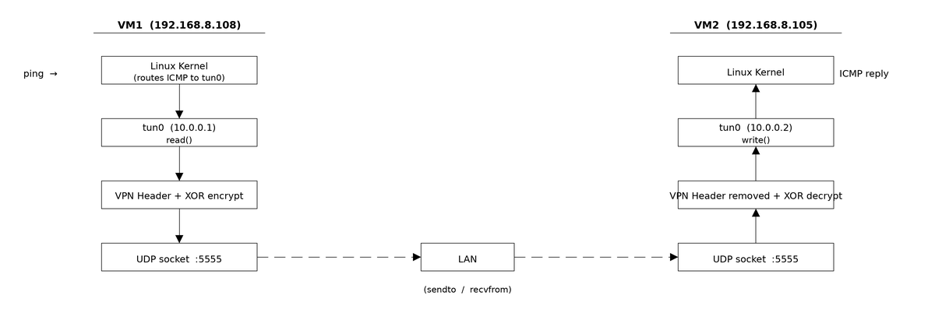Figure 3.1 – End-to-end packet path for a single ICMP echo request traversing the VPN tunnel.
Both directions of traffic are handled by the same event loop using select(), so the diagram above is symmetric an ICMP echo reply generated by MACHINE2's kernel travels back along the mirror-image path, re-entering MACHINE1's networking stack through its own tun0 interface.

3.2 Module Design
The codebase is organized into small, single-responsibility source files, each compiled and linked together by the project Makefile into the final vpn executable (with a second, smaller executable, send_test, used purely for authentication testing). The responsibilities of each file are summarized below.

tun.c / tun.h
Purpose | Create and configure a Linux TUN virtual network interface that the rest of the application can treat as an ordinary file descriptor.
Functions | tun_alloc(char *dev) opens /dev/net/tun, configures it as a Layer-3-only interface (IFF_TUN | IFF_NO_PI) using ioctl(TUNSETIFF), and returns the resulting file descriptor.
Responsibilities | Abstracting away the Linux-specific ioctl() sequence required to bring up a TUN device, so that main.c can simply call tun_alloc() and receive back a usable file descriptor without needing to know the underlying kernel interface.
Table 1 tun.c and tun.h function

udp.c / udp.h
Purpose | Provide the UDP transport primitives used to carry encapsulated VPN packets between the two virtual machines.
Functions | create_udp_socket(int port) creates a SOCK_DGRAM socket and binds it to the given local port on INADDR_ANY, so the program can receive datagrams from any peer address.  send_packet(int sockfd, const char *ip, int port, void *buffer, int len) wraps sendto(), constructing the destination sockaddr_in from a textual IP address and port, and checks the return value to detect and report short or failed sends.
Responsibilities | Hiding the BSD sockets boilerplate (struct sockaddr_in construction, error handling) behind two small functions, and surfacing transmission failures explicitly rather than allowing them to fail silently.
Table 2 udp.c and udp.h function

protocol.c / protocol.h
Purpose | Define the custom VPN protocol the on-the-wire header format and the constants used to identify packet types and authenticate peers.
Responsibilities | Defines vpn_header_t, the structure prepended to every packet sent over the tunnel.  Defines CMD_DATA and CMD_KEEPALIVE, the two recognized command types.  Defines AUTH_TOKEN, the pre-shared authentication string compiled into both peers.  protocol.c itself contains no executable logic beyond including its own header, it exists to keep the wire-format definition isolated from the program logic that uses it, in main.c.
Table 3 protocol.c and protocol.h function

crypto.c / crypto.h
Purpose | Provide a simple, symmetric encryption/decryption transform applied to the payload of every tunneled packet.
Functions | xor_crypt(unsigned char *data, int len) – XORs every byte of the given buffer with a fixed key (0x5A). Because XOR is its own inverse, the same function is used for both encryption and decryption.
Responsibilities | Demonstrating, structurally, where a real encryption algorithm (e.g. AES-256) would be inserted into the pipeline, while keeping the project's cryptographic component simple enough to implement, inspect, and reason about within the project's time constraints.
Table 4 crypto.c and crypto.h function

main.c
Purpose | The core application, owns the TUN interface and UDP socket, runs the main select() event loop, and implements all packet processing logic (encapsulation, encryption, authentication, decryption, decapsulation, keepalive, and timeout handling).
Responsibilities | Parsing the peer IP address from the command line and allocating the TUN interface and UDP socket on startup.  Sending periodic CMD_KEEPALIVE packets and tracking the time of the last keepalive sent and the last packet received, to detect peer timeout and reconnection.  Forwarding TUN to UDP: reading a raw IP packet from tun0, prepending a vpn_header_t (command, sequence number, authentication token), encrypting the payload, and sending it to the peer.  Forwarding UDP to TUN: receiving a datagram, verifying its authentication field against AUTH_TOKEN (rejecting and logging any mismatch together with the sender's IP and port), decrypting the payload if accepted, and writing the recovered IP packet into the local tun0 interface.  Surfacing failures explicitly: checking the return values of read(), write(), sendto(), and recvfrom(), and (during development) hex-dumping packet contents before encryption and after decryption to allow byte-for-byte verification of the encapsulation pipeline.
Table 5 main.c function

send_test.c
Purpose | A standalone diagnostic client used exclusively to test the authentication mechanism, by constructing and sending a VPN-protocol packet directly over UDP without going through a TUN interface at all.
Used to test unauthorized users | By default, send_test deliberately populates the authentication field with an invalid token (INVALID_KEY_0000), simulating a client that does not possess the correct pre-shared key.  An optional third command-line argument allows a specific token to be supplied instead including the correct AUTH_TOKEN which is used to demonstrate, by contrast, that a packet bearing the correct key is accepted while one without it is rejected and logged.  Because send_test bypasses the TUN interface entirely, its packets are not meaningful IP traffic; its sole purpose is to exercise and demonstrate the authentication gate in main.c in isolation, independent of the rest of the tunnel.
Table 6 send_test.c script

CHAPTER 4: IMPLEMENTATION
This chapter documents the implementation as it actually unfolded, organized by development stage rather than by arbitrary task number. Each stage builds directly on the previous one, mirroring the order in which the system was constructed and tested across the two virtual machines.

Stage 1: Creating the TUN Interface
The first stage establishes the virtual network interface that the rest of the system depends on. tun_alloc() opens the kernel's TUN/TAP control device and uses ioctl() with the TUNSETIFF request to create (or attach to) a named interface, configured as a pure Layer-3 device with no additional packet-information header.
IFF_NO_PI removes a 4-byte packet-information prefix that the kernel would otherwise place before every packet, simplifying the rest of the pipeline since every byte read from the descriptor is then guaranteed to be the start of a raw IP packet. Running the resulting program for the first time confirms successful interface creation
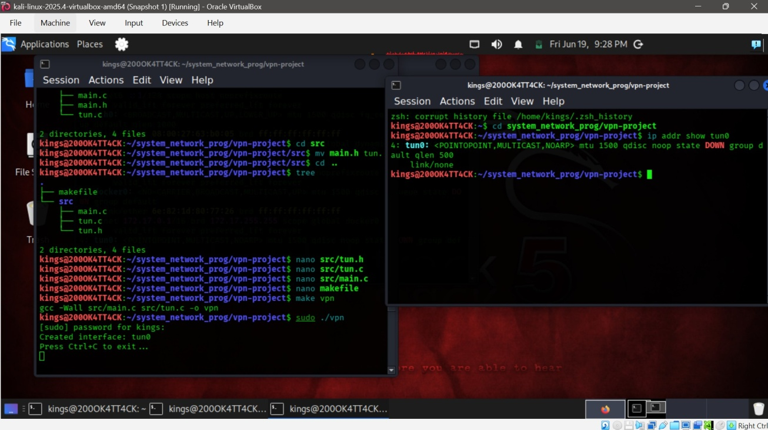
Figure 4.1: Tun interface created.

Stage 2: Configuring the Virtual Interface
Interface creation alone does not make tun0 usable it must be assigned an IP address and brought up using standard Linux iproute2 commands, run once per virtual machine after the program has created the interface. This assigns each peer a private address inside the tunnel's own /24 address space (10.0.0.0/24), distinct from the MACHINEs' real LAN addresses (192.168.8.108 and 192.168.8.105) used by the UDP transport underneath. Verifying the configuration with ip addr show tun0 on MACHINE1 produced:
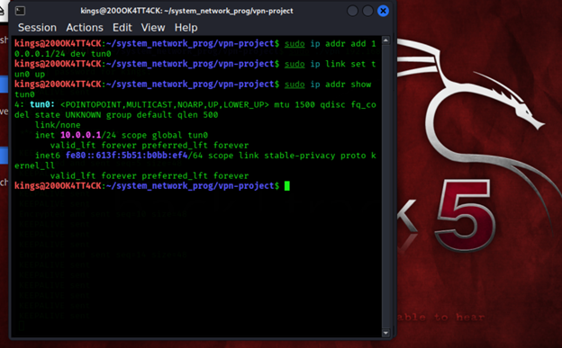
Figure 4.2: configuring Ips that will be used by TUN
It was observed during development that this configuration does not persist across MACHINE reboots or interface restarts each time the vpn process is restarted, a brand-new tun0 instance is created and must be re-addressed and re-enabled. This recurring step is discussed further as a challenge in Chapter 7.

Stage 3: Reading Packets from TUN
With tun0 active, read() on the returned file descriptor blocks until the kernel has a packet to deliver for example, because a local process generated outbound traffic destined for an address routed via tun0. Early testing isolated this single step, reading a packet and printing its length, before any encapsulation logic was added.
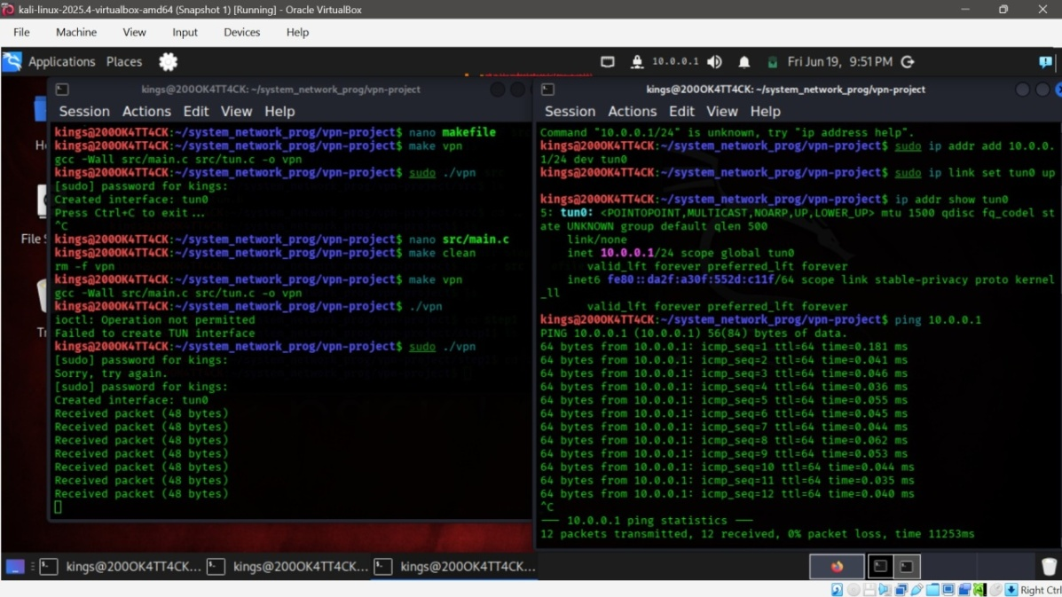
Figure 4.3: machine1 reading packets from TUN

Stage 4: UDP Socket Communication
In parallel with TUN development, a UDP socket pair was established and tested independently of the tunnel logic, to confirm basic MACHINE-to-MACHINE reachability on port 5555 before adding any protocol complexity. create_udp_socket() wraps socket() and bind():
Initial connectivity was verified using netcat in UDP mode (nc -u) between the two MACHINEs before any custom code was trusted, confirming that port 5555 was reachable across the LAN and that no firewall rule was silently discarding traffic in either direction
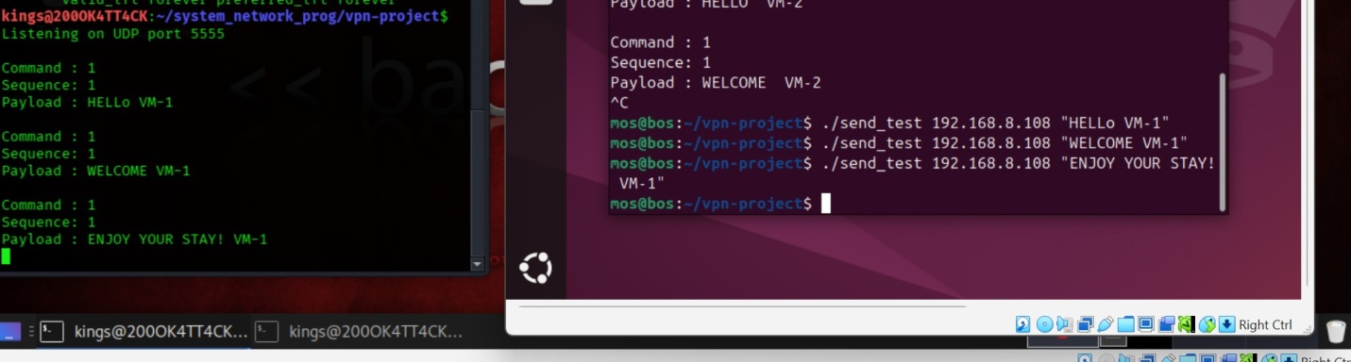
Figure 4.4.1: machine1 and 2 communicating via UDP sockets
Once raw UDP connectivity was confirmed, send_packet() (wrapping sendto()) and the receiving side's recvfrom() call were integrated into the main program in place of the netcat test.
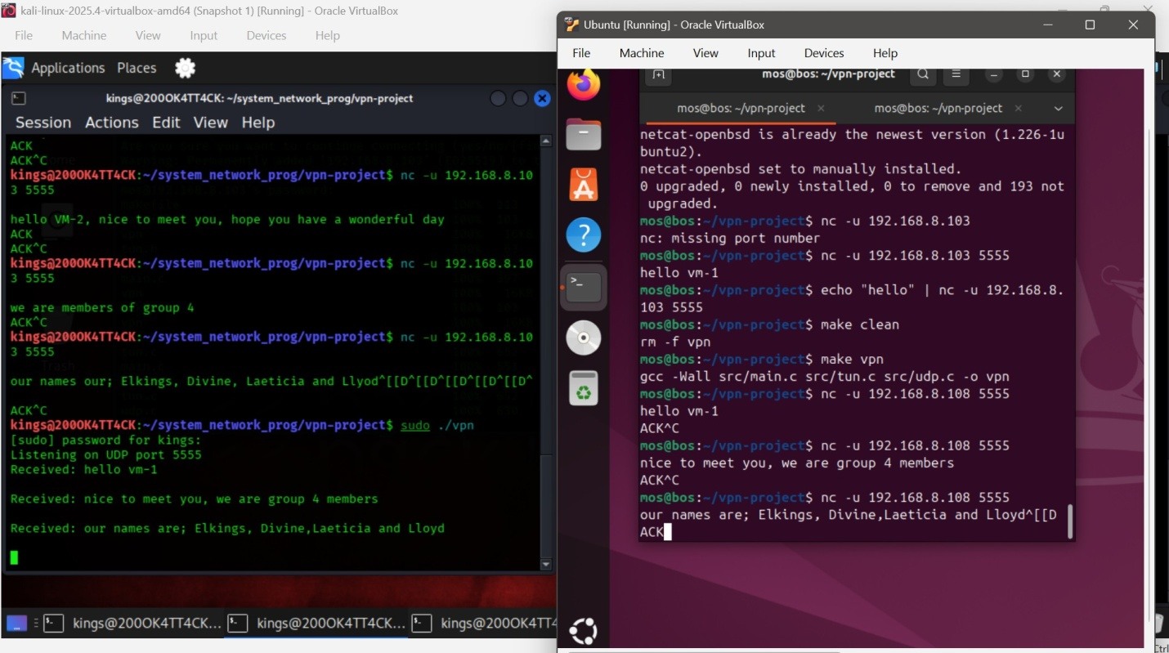
Figure 4.4.2: machine1 and 2 communicating via UDP listening port

Stage 5: Custom VPN Protocol
To carry more than an undifferentiated byte stream, a fixed-size header, vpn_header_t, is prepended to every packet before it is sent over UDP
Each field exists for a distinct reason. The command field allows the receiver to distinguish ordinary tunneled data from protocol-control traffic (keepalives) without inspecting the payload at all, which matters because keepalive packets carry no IP payload to decrypt or forward. The sequence field is a monotonically increasing counter, incremented on every packet sent (including keepalives), intended to support ordering diagnostics during development and to provide the foundation for replay-attack detection, discussed further in Chapter 9. The auth field carries a fixed-size, null-terminated copy of the shared secret AUTH_TOKEN, and is the field inspected by the authentication gate described in Stage 10.
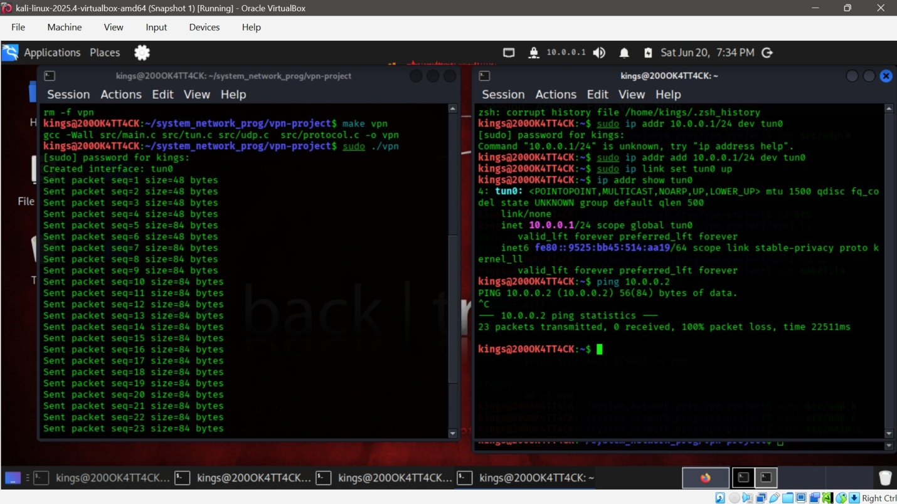Figure 4.5: packets being sent with fixed sizes

Stage 6: Packet Encapsulation
Encapsulation in this codebase is implemented by writing the header directly into the front of the same buffer that will hold the payload, rather than using separate buffers that would need to be copied together. Conceptually:
Original IP Packet (n bytes, captured via read(tun_fd,...)) move to vpn_header_t (original n bytes, now XOR-encrypted) and move to UDP Packet (sizeof(vpn_header_t) + n bytes total)
This is implemented by reading directly into packet + sizeof(vpn_header_t), leaving room at the front of the buffer for the header fields to be populated afterward, and then passing the combined length (n + sizeof(vpn_header_t)) to send_packet(). The receiver performs the inverse calculation, subtracting sizeof(vpn_header_t) from the number of bytes received to recover the original payload length before decryption.

Stage 7: Bidirectional Tunnel
The two directions of traffic TUN to UDP and UDP to TUN are serviced within a single select() loop. Both the TUN file descriptor and the UDP socket are added to the same fd_set; whichever is reported ready by select() is processed in that iteration of the loop, and the loop iterates continuously with a one-second timeout so that time-based logic (keepalives, timeout detection) is also evaluated regularly even when no traffic is flowing:
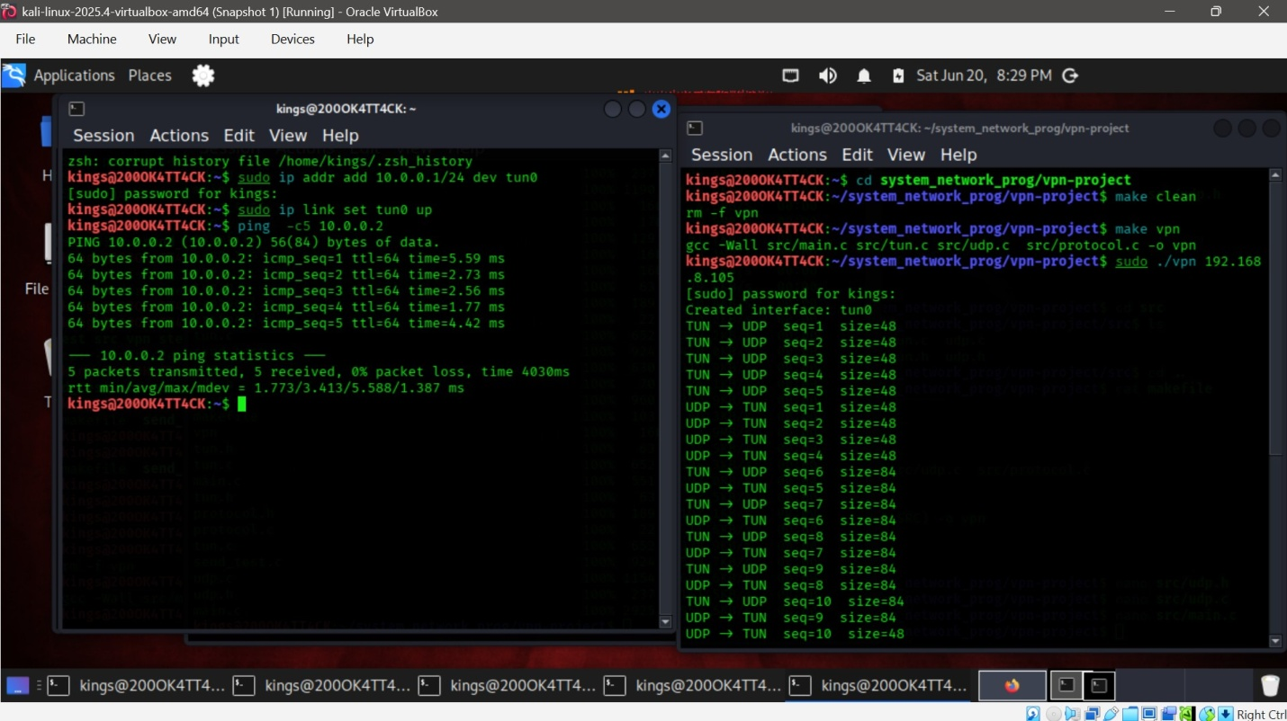
Figure 4.7: TUN-UDP bidirectional traffic
This event-driven structure means the program never blocks indefinitely on either direction; a packet arriving on either descriptor is serviced promptly without the complexity of a multi-threaded design, which is appropriate given that the program has no CPU-bound work and is purely I/O-bound.

Stage 8: Encryption
Confidentiality is provided by a single-byte XOR cipher applied to the payload portion of every packet (the header itself is left in plaintext, since the receiver must be able to read the command and authentication fields before any decryption can take place):
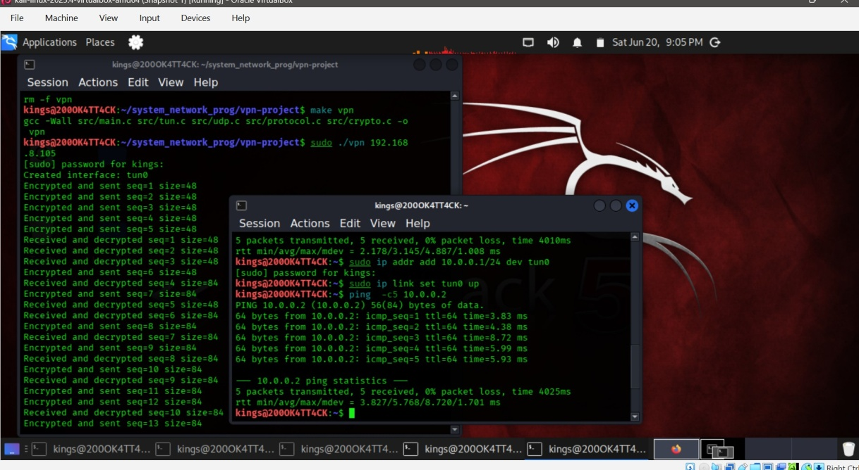
Figure 4.8:packets being encrypted before being sent over the tunnel.
Because A ⊕ K ⊕ K = A for any byte A and key K, the same function performs both encryption (sender) and decryption (receiver) xor_crypt() is called once on the sending side before transmission and once on the receiving side after reception, with identical arguments and identical effect in reverse. During development, the payload was hex-dumped immediately before encryption on the sender and immediately after decryption on the receiver; the two dumps were confirmed to be byte-for-byte identical, validating that the encrypt/decrypt round trip introduces no corruption:
The limitations of this approach are significant and are discussed in depth in Section 8.4, XOR with a single static key provides no real confidentiality against any attacker capable of capturing more than a small amount of traffic, since the fixed key can be recovered through straightforward frequency or known-plaintext analysis. It is used here purely to demonstrate, structurally, where a real cipher would be inserted into the pipeline.

Stage 9: Keepalive Packets
To detect a dead or unreachable peer independently of whether the user happens to be generating traffic at the time, the program sends a CMD_KEEPALIVE packet automatically every 5 seconds. If no packet of any kind (data or keepalive) has been received from the peer for more than 15 seconds, the peer is marked as no longer alive and a timeout is logged, if a packet subsequently arrives, the peer is marked alive again and a reconnection is logged:
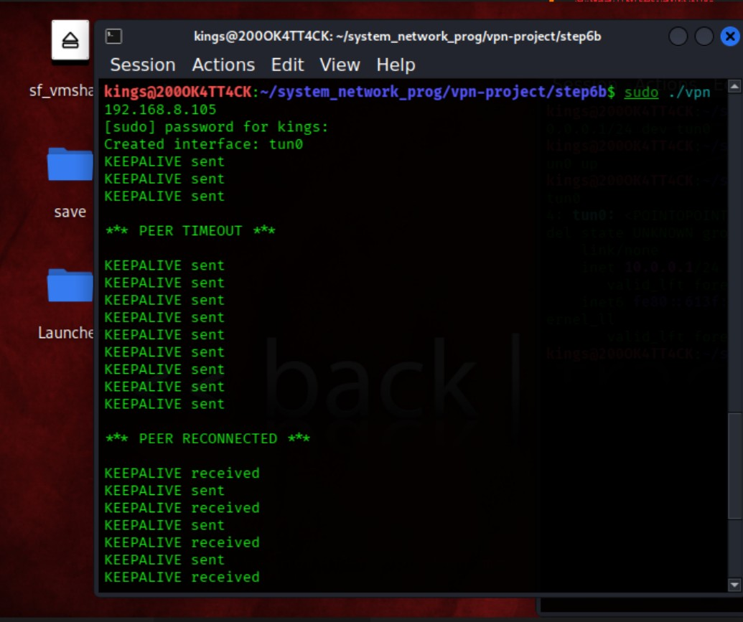
Figure 4.9: keepalive packets being exchanged between two machines to test connectivity
This behavior was observed directly in the application logs during testing, including a deliberate interruption of one peer to trigger a timeout and subsequent reconnection:

Stage 10: Authentication
Every outgoing packet, whether CMD_DATA or CMD_KEEPALIVE, has its auth field populated with the pre-shared token defined in protocol.h: #define AUTH_TOKEN "GROUP4VPN2026"
On reception, before a packet's payload is touched at all, the receiver compares the packet's auth field against AUTH_TOKEN. In the version of the code validated for this report, this comparison is implemented with a length-bounded memcmp() (rather than a null-terminator-dependent strcmp()), which is both more defensive against malformed input and, critically, also logs the rejecting source address and port so that an unauthorized access attempt is fully attributable in the log:
A dedicated test utility, send_test.c, was written specifically to demonstrate this gate. By default it deliberately constructs a packet carrying an invalid token (simulating a client without the pre-shared key), an optional third command-line argument allows the correct token to be supplied instead, for contrast.
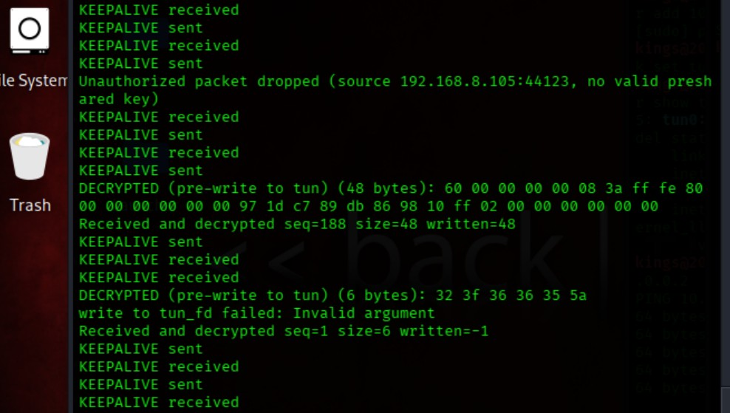
Figure 4.10: packet with correct preshared key being decrypted in the tunnel
Running the unauthorized case while the VPN process was active and visible in a separate terminal produced the following log entries, captured directly from a live test run, demonstrating that an unauthorized client is identified, rejected, and logged together with its source IP address and port
By contrast, a packet carrying the correct token was accepted: no rejection was logged, the payload was decrypted, and the program proceeded to attempt to write the (synthetic, non-IP) payload into tun0,
which the kernel correctly rejected as malformed at the IP layer expected behavior, since send_test sends a plain text string rather than a real IP packet, and is included here purely to exercise the authentication gate rather than to produce meaningful tunneled traffic.

Stage 11: End-to-End VPN Testing
With every preceding stage integrated, the system was tested using the standard ping utility directed at the peer's tunnel address, with the VPN process running on both virtual machines simultaneously:
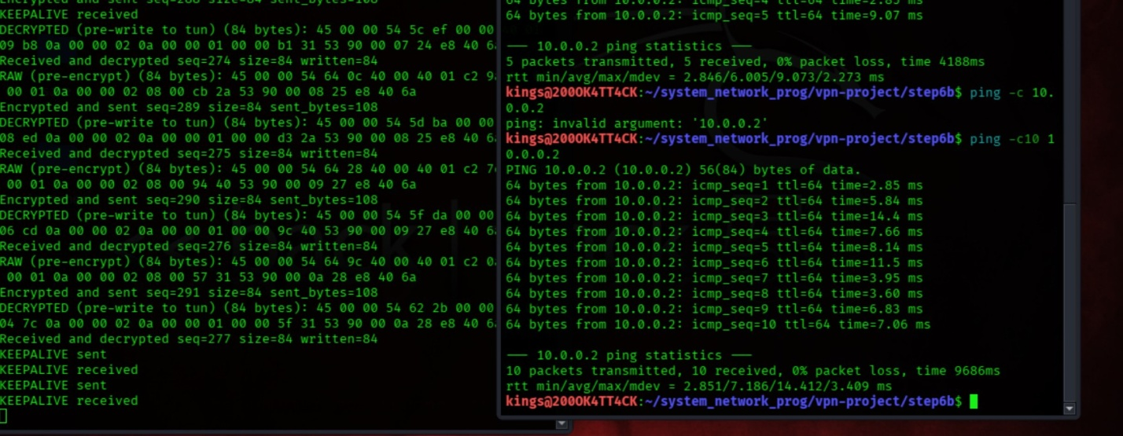
Figure 4.11.1: packet being encrypted before sent and decrypted when received

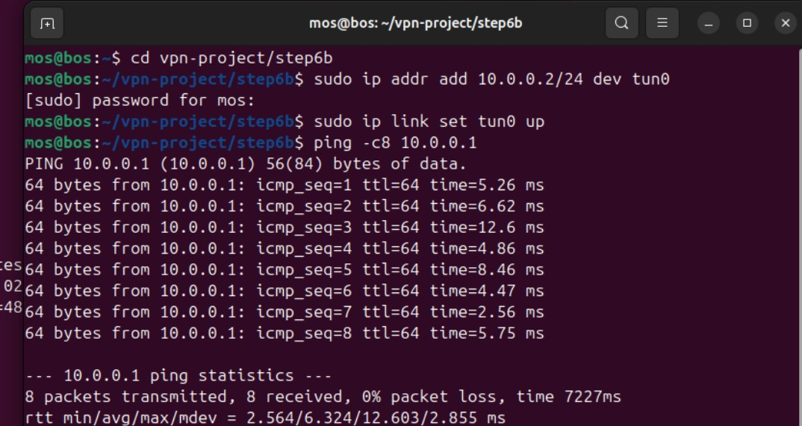
Figure 4.11.2: machine 2 being able to ping to machine 1 and vice versa
Correspondingly, the application log on the receiving peer showed the full pipeline operating on real ICMP traffic, including matched encryption and decryption events and successful writes back into the local TUN interface:
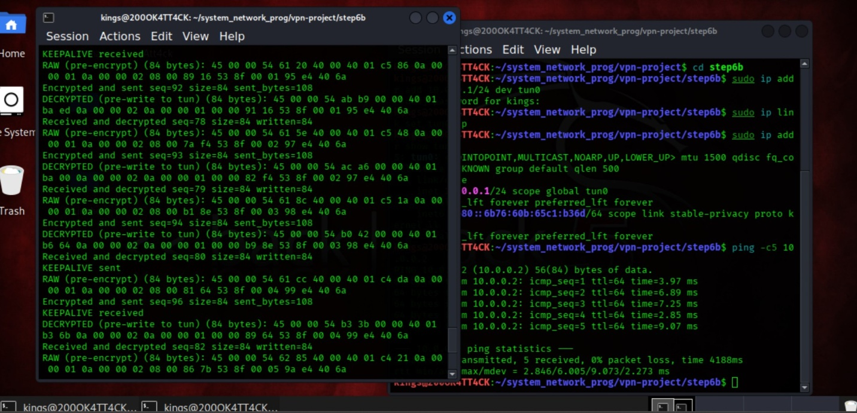
Figure 4.11.3: packets being encrypted and decrypted as they are sent and received within the network

This confirms, end to end, that an ICMP echo request generated by the operating system on MACHINE1 was captured from tun0, encapsulated, encrypted, transmitted over UDP, received and authenticated on MACHINE2, decrypted, and re-injected into MACHINE2's own tun0 where MACHINE2's kernel generated a genuine ICMP echo reply that traversed the identical pipeline in reverse, was received by MACHINE1's kernel, and was reported by ping as a successful round trip.

CHAPTER 5: TESTING AND RESULTS
Testing was carried out incrementally, alongside development, rather than as a single pass at the end of the project. Each stage described in Chapter 5 was validated in isolation before being integrated with the next, using a combination of application-level logging, the standard ping utility, and packet capture with tcpdump on both the tun0 and eth0 interfaces of each virtual machine. Table 6.1 summarizes every test performed, the expected outcome, the actual evidence observed, and the final status of each.
Test | Expected | Actual / Evidence | Status
TUN interface creation | tun0 created successfully on both MACHINEs | Created interface tun0 printed; interface visible via ip addr | Pass
UDP communication (netcat) | Datagrams exchanged between MACHINE1 and MACHINE2 on port 5555 | Message sent with nc -u received correctly on peer | Pass
Custom header parsing | Receiver correctly reads command, sequence, auth fields | Fields read consistently on both peers; no offset mismatch observed | Pass
Packet encapsulation/decapsulation | Header added before send, removed before write back to TUN | Verified via payload length arithmetic (n + sizeof(vpn_header_t)) | Pass
Encryption (XOR) | Payload unreadable in transit, reversible on receipt | Pre-encrypt and post-decrypt hexdumps matched byte-for-byte | Pass
Decryption | Original payload exactly recovered after decrypt | Confirmed via hexdump comparison across multiple packets | Pass
Bidirectional forwarding | TUN t0 UDP and UDP toTUN both function in the same run | select() loop serviced both directions concurrently | Pass
Keepalive transmission | KEEPALIVE sent every 5 seconds | “KEEPALIVE sent” logged at regular intervals | Pass
Timeout detection | Peer marked dead after 15s of silence | “*** PEER TIMEOUT ***” logged after induced peer interruption | Pass
Reconnection detection | Peer marked alive again on first packet received | “*** PEER RECONNECTED ***” logged correctly | Pass
Authentication, invalid key rejected | Packet with wrong/missing token dropped and logged with source IP | “Unauthorized packet dropped (source 192.168.8.105:57255, ...)” | Pass
Authentication ,valid key accepted | Packet with correct AUTH_TOKEN passes the gate | No rejection logged; payload proceeded to decrypt/write stage | Pass
End-to-end ping over VPN | ping across tun0 addresses succeeds with low loss | 5 packets transmitted, 5 received, 0% packet loss | Pass
Reverse-path packet delivery | ICMP replies generated by MACHINE2 reach MACHINE1's stack | Initially failed (see Challenge 7.4); resolved after troubleshooting | Pass
Table 7 Summary of tests performed across all project stages.
The reverse-path packet delivery test initially failed even though every individual pipeline stage (encryption, decryption, header parsing) tested correctly in isolation this is documented in detail as Challenge 7.4, since the eventual diagnosis (a silently failing write() to the TUN device that was not being checked) is itself an important testing lesson a log line confirming that a function was called is not evidence that it succeeded. Once write() and sendto() return values were explicitly checked and packet contents hex-dumped at each transformation boundary, the true point of failure became directly observable rather than inferred.
The authentication tests were similarly only made fully verifiable once a dedicated test client (send_test.c) was modified to deliberately and reproducibly send invalid credentials, rather than relying on a generic UDP message whose authentication field happened to contain unpredictable, uninitialized stack memory.

CHAPTER 6: CHALLENGES ENCOUNTERED
This project surfaced a series of genuine, non-trivial problems, several of which took multiple debugging sessions to resolve. They are documented here in the Problem / Cause / Solution format, both because they represent real learning outcomes and because future maintainers of this codebase are likely to encounter the same class of issues.

6.1 UDP Communication Initially Failing
Problem: Early attempts to verify basic UDP reachability between the two MACHINEs appeared to fail, with no data observed arriving at the receiving end.
Cause: The initial testing method using netcat was applied inconsistently between the two ends (mismatched flags / one side not actually in listening mode), giving the appearance of a network-level failure when the issue was in how the test itself was invoked.
Solution: Standardized the netcat test procedure explicitly (nc -u -l <port> on the receiver, echo ... | nc -u <ip> <port> on the sender) and confirmed connectivity at this layer before writing or trusting any custom socket code, isolating transport-layer reachability from application-layer bugs.

6.2 DHCP Changing MACHINE IP Addresses After Reboot
Problem: Commands and configuration that worked in one session failed after a MACHINE reboot, with connection attempts going to an address that no longer belonged to the intended peer.
Cause: Both MACHINEs obtained their LAN-facing IP address via DHCP, which is not guaranteed to reassign the same address after a reboot or after a lease renewal.
Solution: Re-verified each MACHINE's current LAN IP address with ip addr show before every testing session, and treated the peer IP argument passed to the vpn program as session-specific rather than assuming it was fixed for the life of the project.

6.3 TUN Interface Remaining Down After Restart
Problem: After restarting the vpn process, the tunnel appeared inactive even though the program reported successful interface creation.
Cause: Each invocation of tun_alloc() creates a fresh tun0 instance with no IP address and no “up” state; the earlier ip addr add and ip link set up configuration does not persist across the interface being torn down and recreated.
Solution: Re-ran the ip addr add and ip link set up commands after every restart of the vpn process, and documented this as a required manual step in the standard test procedure

6.4 Packets Transmitted but Ping Failing (Reverse Path Not Re-Injected)
Problem: tcpdump confirmed that ICMP echo requests left MACHINE1's tun0 and that UDP packets carrying them arrived on MACHINE2's eth0 tcpdump on MACHINE2 even showed the kernel generating a corresponding ICMP echo reply. Despite this, ping on MACHINE1 consistently reported 100% packet loss.
Cause: The forward path of the tunnel (MACHINE1 to MACHINE2) was being verified end-to-end, but the reverse path (MACHINE2 to MACHINE1) was only being verified up to the point where MACHINE2's kernel generated a reply whether that reply was actually picked up from tun0, re-encapsulated, and successfully delivered back to MACHINE1 had never been directly confirmed. The root cause was that write() calls to the TUN device were not having their return value checked, so a silently failing write (which did occur for certain non-IPv4 traffic, and could equally have masked a real fault) would have produced no visible error.
Solution: Added explicit return-value checking on read(), write(), sendto(), and recvfrom() throughout main.c, together with hex dumps of the payload immediately before encryption and immediately after decryption. This made every stage of both directions independently observable rather than inferred from indirect evidence, which is what ultimately confirmed the full round trip was completing correctly once the remaining issues (see 7.5 and 7.6) were also resolved.

6.5 Stale Compiled Binaries Masking Working Code
Problem: After updating main.c and send_test.c to add authentication logging, repeated test runs still showed no “Unauthorized packet dropped” message at all, even though a manual code review confirmed the logic was correct.
Cause: The updated source files had been edited but the corresponding binaries (vpn and send_test) had not been rebuilt, so the MACHINE continued to execute the previous version of the program. This was confirmed conclusively when the running send_test binary printed an old usage message that did not exist anywhere in the current source file.
Solution: Adopted a strict rebuild discipline: make clean followed by a full make (or make all) immediately before every test run, and added a quick sanity check grepping the source file for a string known to exist only in the new version to positively confirm which version of the code was actually on disk before trusting any test result.

6.6 Incomplete Makefile Silently Building the Wrong Binary
Problem: Running make send_test sometimes reported “Nothing to be done”, sometimes fell back to a generic compilation rule and produced a binary in the wrong directory (inside src/ rather than the project root), and at one point failed outright with “No rule to make target 'send_test'”.
Cause: The project's Makefile originally defined only a vpn target and a clean target; there was no send_test rule at all. In the absence of an explicit rule, make's built-in implicit rules occasionally matched and silently compiled send_test.c on their own, in whatever directory the command happened to be run from, producing a binary that looked plausible but was not the one the rest of the workflow expected to find.
Solution: Rewrote the Makefile to define an explicit send_test target (compiling send_test.c together with udp.c and protocol.c, since the test client does not need tun.c, crypto.c, or main.c), added an all target building both binaries, and extended clean to remove both. Stray binaries that had been built in the wrong location by the implicit rule were deleted manually before re-testing.

6.7 Synchronizing Code Updates Between Two Independent MACHINEs
Problem: On several occasions, a fix verified as working on one MACHINE appeared not to take effect when testing resumed, or one MACHINE behaved differently from the other despite both supposedly running the same code.
Cause: MACHINE1 and MACHINE2 are independent filesystems with no shared mount; every source change has to be explicitly propagated using scp -r and then rebuilt separately on the destination machine. It was easy for an edit-test-fix cycle on one MACHINE to be lost or only partially copied across before the next test.
Solution: Adopted an explicit, repeatable propagation sequence rebuild and sanity-check on the originating MACHINE first, then scp -r the updated src/ and makefile to the peer MACHINE, then rebuild there too before any cross-MACHINE test (such as the authentication or ping tests) was considered valid.

CHAPTER 7: DISCUSSION

7.1 Why UDP Was Chosen
UDP was selected as the VPN's transport protocol because the system being built is, structurally, a tunnel for other protocols' traffic rather than a single application-level conversation. As discussed in Section 3.3, layering one reliable, ordered transport (TCP, used by the application generating the original traffic) inside another reliable, ordered transport (TCP, used as the VPN's own carrier) produces the well-documented TCP-over-TCP problem, where two independent congestion-control and retransmission loops interact destructively under loss. UDP's lower overhead and lack of head-of-line blocking make it the conventional choice for VPN transport in practice, as seen in both OpenVPN's UDP mode and WireGuard's UDP-only design, and this project follows that same convention deliberately rather than by default.

7.2 Why TUN Instead of TAP
The project's scope is limited to tunneling IP traffic between two hosts, demonstrated using ICMP, there is no requirement to carry non-IP protocols or to emulate a shared Ethernet broadcast domain between the two virtual machines. TUN's Layer-3-only framing is therefore sufficient and avoids the additional 14-byte Ethernet header and ARP-handling complexity that a TAP-based design would otherwise introduce for no corresponding benefit in this context.

7.3 Why a Custom Protocol Was Implemented
Rather than tunneling raw IP packets directly inside bare UDP datagrams, a small custom header (vpn_header_t) was introduced specifically so that the receiver could distinguish packet types (data versus keepalive), track packet order, and authenticate the sender before any payload processing occurs. Without this header, the system would have no way to reject unauthorized traffic, no way to distinguish a liveness probe from real data, and no foundation on which to later add replay protection all of which were explicit project objectives.

7.4 Limitations of XOR Encryption
The XOR cipher used in this project provides effectively no real confidentiality. Because a single fixed one-byte key is reused for every byte of every packet, any sufficiently large captured payload is trivially breakable using frequency analysis (the most common byte in typical IP/ICMP payloads, often 0x00, immediately reveals the key once XORed against the most common ciphertext byte), and is completely broken by an attacker who can obtain even a single short known-plaintext fragment. It also provides no integrity protection whatsoever an attacker who flips arbitrary bits in a captured ciphertext produces a payload that decrypts to corrupted-but-plausible-looking data with no detectable error, since XOR has no concept of a valid or invalid decryption. This cipher was used deliberately as a structural placeholder, to demonstrate where and how a real cipher integrates into the pipeline, and should not be interpreted as providing any real security guarantee, Chapter 9 discusses AES-256 and ChaCha20 as direct, drop-in replacements for the same xor_crypt() call site.

7.5 Limitations of a Pre-Shared Authentication Token
The authentication mechanism implemented in this project was a single static string, compiled directly into both peers and compared on every packet and it is sufficient to demonstrate the concept of peer authentication and to reliably reject and log traffic from a peer that does not possess it, as shown in Section 5, Stage 10. However, it has several properties that make it unsuitable as a real security boundary. The token is identical and unchanging for the lifetime of the binary, anyone who obtains a copy of the compiled program or its source can extract it directly, with no cryptographic effort required. The token is also transmitted in essentially plaintext form inside the (XOR-encrypted, but trivially breakable) packet header on every single packet, giving a network observer repeated opportunities to recover it. Finally, because the same fixed value is accepted indefinitely, a captured packet including its valid authentication field could be replayed by an attacker at any later time with no mechanism in the current implementation to detect that it is a. However, the mechanism is appropriate for this projects but should be clearly distinguished from genuine cryptographic peer authentication, which would require a non-replayable challenge, a per-session derived key, or a proper key-exchange protocol such as Diffie–Hellman.

7.6 Comparison with Production VPNs
Production VPN protocols such as OpenVPN and WireGuard solve the same structural problem tunneling, encrypting, and authenticating traffic between peers but address the limitations discussed above directly. WireGuard, for example, uses the Noise protocol framework to perform an authenticated Diffie–Hellman key exchange between long-term static keys, deriving fresh, short-lived symmetric session keys that are periodically rotated, it encrypts and authenticates every packet using ChaCha20-Poly1305, an authenticated encryption construction that detects tampering rather than silently accepting corrupted ciphertext and it includes a strict, built-in replay-protection window based on packet counters. OpenVPN similarly supports TLS-based key negotiation, certificate-based peer authentication, and HMAC-based packet integrity. This project implements simplified, structurally basic versions of several of these ideas, a protocol header carrying a sequence counter, a basic shared-secret authentication gate, and a symmetric cipher applied to the payload specifically so that the underlying concepts could be implemented and inspected directly, while explicitly avoiding the false impression that these simplified mechanisms are production-ready replacements for the cryptographic protocols used in real-world VPN software.

CHAPTER 8: FUTURE IMPROVEMENTS
The following improvements were identified during development and discussion as the most direct next steps for extending this project beyond its current scope.
- Replace XOR with AES-256 or ChaCha20. The xor_crypt() call site in main.c is already structurally isolated (encrypt-before-send, decrypt-after-receive on the payload only), so a real authenticated cipher could be substituted with minimal changes to the surrounding control flow, immediately removing the confidentiality and integrity weaknesses discussed in Section 8.4.
- Add HMAC-based packet integrity. Appending an HMAC computed over the header and ciphertext, and verifying it before decryption, would let the receiver detect tampered or corrupted packets explicitly, rather than silently decrypting and forwarding corrupted data as the current XOR-only design does.
- Implement a proper key exchange, such as Diffie–Hellman. Replacing the static AUTH_TOKEN with a per-session key derived from an authenticated key exchange would remove the single biggest weakness identified in Section 8.5, a fixed secret that, once extracted, grants indefinite access.
- Add configuration files instead of hard-coded values. AUTH_TOKEN, the listening port, the keepalive interval, and the peer timeout are all currently compile-time constants; moving these into an external configuration file would allow the same binary to be redeployed with different security and timing parameters without recompilation.
- Implement automatic routing and interface configuration. The ip addr add / ip link set up steps documented in Stage 2 and Challenge 7.3 are currently manual and must be repeated after every restart having the program perform this configuration itself at startup (via further ioctl() or netlink calls) would remove a recurring source of operator error.
- Compress payloads before encryption. Applying a general-purpose compression pass to the IP payload before the encryption stage could reduce tunnel bandwidth for compressible traffic, mirroring an optional feature available in several production VPN implementations.
- Add a graphical management interface. A simple dashboard showing current peer status (alive/timed out), recent unauthorized access attempts (building directly on the source-IP logging already implemented in Stage 10), and basic throughput statistics would make the system considerably more usable for anyone other than its original developer.

CONCLUSION
This project set out to design and implement a lightweight Virtual Private Network using Linux TUN interfaces and UDP sockets in C, with the explicit goal of understanding VPN internals through direct construction rather than through configuration of existing software. Every specific objective stated in Chapter 2 was met, virtual network interfaces were created and configured on two independent virtual machines, raw IP traffic was successfully tunneled through a UDP transport a custom protocol header was designed and implemented to carry command, sequence, and authentication information, full bidirectional communication was achieved using a single select()-based event loop payloads were encrypted and decrypted using a symmetric cipher, peer failures and recoveries were detected automatically via keepalive packets and timeout logic unauthorized peers were authenticated against, and rejected with full source-address logging and secure, authenticated, end-to-end communication was demonstrated conclusively through successful ping traffic across the tunnel with 0% packet loss.
Overall we are thankful to our lecturer for giving us this opportunity in testing our know-how as we learned so many things from the project including team collaboration, time management, working under duress and many others and at the end of the day, we could say this project and course was a SUCCESS

REFERNCES
Link to github repo https://github.com/ElkingsDom/CEF488-System-and-Network-programming-
Linux TUN/TAP Driver Documentation. The Linux Kernel Documentation Project. Available at: https://www.kernel.org/doc/Documentation/networking/tuntap.txt
Linux Programmer's Manual – ioctl(2). Available at: https://man7.org/linux/man-pages/man2/ioctl.2.html
Postel, J. (1980). RFC 768 – User Datagram Protocol. Internet Engineering Task Force (IETF).
Postel, J. (1981). RFC 791 – Internet Protocol. Internet Engineering Task Force (IETF).
Postel, J. (1981). RFC 792 – Internet Control Message Protocol. Internet Engineering Task Force (IETF).
Donenfeld, J. A. (2017). WireGuard: Next Generation Kernel Network Tunnel. Proceedings of the Network and Distributed System Security Symposium (NDSS).
OpenVPN Technologies, Inc. OpenVPN Community Documentation. Available at: https://openvpn.net/community-resources/
Lecture notes and laboratory materials, Systems and Network Programming course

Appendix A: Complete Source Code Listing

The project was built stepwise, one step lead to another and the main steps can be summarized below;

Step 1TUN Interface Creation: Created the Linux TUN interface (tun0), learned how to configure it using ip addr and ip link, verified that the virtual interface was successfully created

Step 2 UDP Socket Communication: Created UDP sockets, implemented a UDP server and client , tested communication using netcat (nc), verified that packets could travel between Machine1 and Machine2

Step Custom VPN Protocol: Designed the VPN protocol header, Added features such as; Command field, Sequence number, created protocol.h and protocol.c, built and tested using send_test.c

Step 4A Packet Encapsulation: Encapsulated TUN packets inside the custom VPN protocol, added protocol headers before transmission, verified packet reception and header parsing

Step 4B Full VPN Tunnel:

Step 4B.1 saw TUN forwarding to UDP

Step 4B.2: saw UDP forwarding TUN

Step 5 Encryption:Implemented XOR encryption, encrypted payload before transmission, decrypted payload after reception , verified successful encrypted communication

Step 6A Keepalive and Peer Monitoring: Added periodic keepalive packets, implemented peer timeout detection , added peer reconnection detection, ensured tunnel status could be monitored

Step 6B Authentication:Added a pre-shared authentication token called the AUTH_TOKEN, extended the VPN header with an authentication field, implemented packet authentication, dropped unauthorized packets, Used send_test.c to verify that invalid authentication tokens were rejected

The full source code for this project is submitted alongside this report as a separate archive (src/ directory plus the project makefile). The table below summarizes the role of each file.

File | Role
makefile | Build configuration; defines the vpn and send_test targets and their source dependencies.
src/main.c | Core application: TUN/UDP event loop, encapsulation, encryption, authentication, keepalive logic.
src/tun.c / tun.h | TUN interface allocation via /dev/net/tun and ioctl(TUNSETIFF).
src/udp.c / udp.h | UDP socket creation, binding, and datagram send wrapper with error checking.
src/protocol.c / protocol.h | VPN packet header definition (vpn_header_t), command constants, and AUTH_TOKEN.
src/crypto.c / crypto.h | XOR-based symmetric encryption/decryption of packet payloads.
src/send_test.c | Standalone test client used to demonstrate authentication acceptance/rejection.
Table 8 Summary of tests performed across all project stages.

Appendix B: Build and Execution Commands

Cmds in building, compiling and executing the files.

make clean remove previously built binaries (vpn, send_test)
make vpn build the main VPN executable
make send_test build the authentication test client

Launching the VPN (run on both MACHINE1 and MACHINE2)

sudo ./vpn <peer-ip>
e.g. on MACHINE1: sudo ./vpn 192.168.8.105
e.g. on MACHINE2: sudo ./vpn 192.168.8.108

Configuring the Tunnel Interface (run after every restart of ./vpn)

On MACHINE1
sudo ip addr add 10.0.0.1/24 dev tun0
sudo ip link set tun0 up
On MACHINE2
sudo ip addr add 10.0.0.2/24 dev tun0
sudo ip link set tun0 up

End-to-End Testing

ping -c5 10.0.0.2 from MACHINE1, tests the full tunnel if it communicates with MACHINE2
tcpdump -i tun0 -n observe plaintext IP traffic entering/leaving the tunnel
tcpdump -i eth0 udp port 5555 observe encapsulated, encrypted traffic on the LAN

Authentication Demonstration

./send_test <peer-ip> "hello" sends an INVALID key , should be rejected and logged
./send_test <peer-ip> "hello" "GROUP4VPN2026" sends the CORRECT key , accepted, no rejection logged

Synchronizing Code Between MACHINEs
scp -r src makefile kings@<peer-ip>:~/system_network_prog/vpn-project @mos192.168.8.105:~
make clean && make all

Appendix C: VPN Protocol Header Definition and Packet Format

Header Structure (protocol.h)

#define CMD_DATA 1
#define CMD_KEEPALIVE 2
#define AUTH_TOKEN "GROUP4VPN2026"
typedef struct
{
uint8_t command; /* CMD_DATA (1) or CMD_KEEPALIVE (2) */
uint32_t sequence; /* monotonically increasing per-sender counter, network byte order */
char auth[16]; /* null-terminated pre-shared authentication token */
} vpn_header_t;

Field Reference
Field | Type | Purpose
command | uint8_t (1 byte) | Identifies the packet as ordinary tunneled data (CMD_DATA) or a liveness probe (CMD_KEEPALIVE) carrying no IP payload.
sequence | uint32_t (4 bytes) | Incremented on every packet sent by a given peer; sent in network byte order via htonl()/ntohl(). Currently logged on receipt but not yet enforced; see Future Improvements, Item 4, for replay-protection use.
auth | char[16] | Holds a copy of AUTH_TOKEN, written with strcpy() on the sending side and verified with a length-bounded memcmp() against AUTH_TOKEN on the receiving side before any further processing of the packet.
Table 9 Summary of tests performed across all project stages.

On-the-Wire Packet Format as it travels in the tunnel
| command (1B) | sequence (4B) | auth (16B) | encrypted payload (n B) |

Appendix D: Test Cases and Expected Outcomes
The table below consolidates the independent test cases exercised during development into a single reference table, distinct from the stage-by-stage narrative testing summary in Table 6.1. Each test case reflects a specific scenario actually run against the implementation described in this report.
Test Case | Expected Outcome | Result
Send a data packet with the correct AUTH_TOKEN | Packet accepted payload, decrypted, no rejection logged | success
Send a data packet with an incorrect/missing token (default send_test behavior) | “Unauthorized packet dropped (source <ip>:<port>, no valid preshared key)” logged; payload discarded | success
Stop the peer process for >15 seconds | “*** PEER TIMEOUT ***” logged once the 15-second threshold is exceeded | success
Resume the peer process after a timeout | “*** PEER RECONNECTED ***” logged on the first packet received afterward | success
Ping the peer's tun0 address across the tunnel | ICMP echo replies received; 0% packet loss reported by ping | success
Compare pre-encryption and post-decryption payload bytes for the same packet | Byte sequences identical (hexdump comparison) | success
Run make send_test with an out-of-date Makefile (no rule defined) | Build fails with “No rule to make target”, correctly surfacing a configuration problem | success (after Makefile fix)
Run send_test against a peer with no vpn process listening | No log output anywhere; demonstrates that authentication logging requires an active listener, not a code defect | success (expected behavior)
Table 10: overall outcomes

Appendix E: Physical Testing
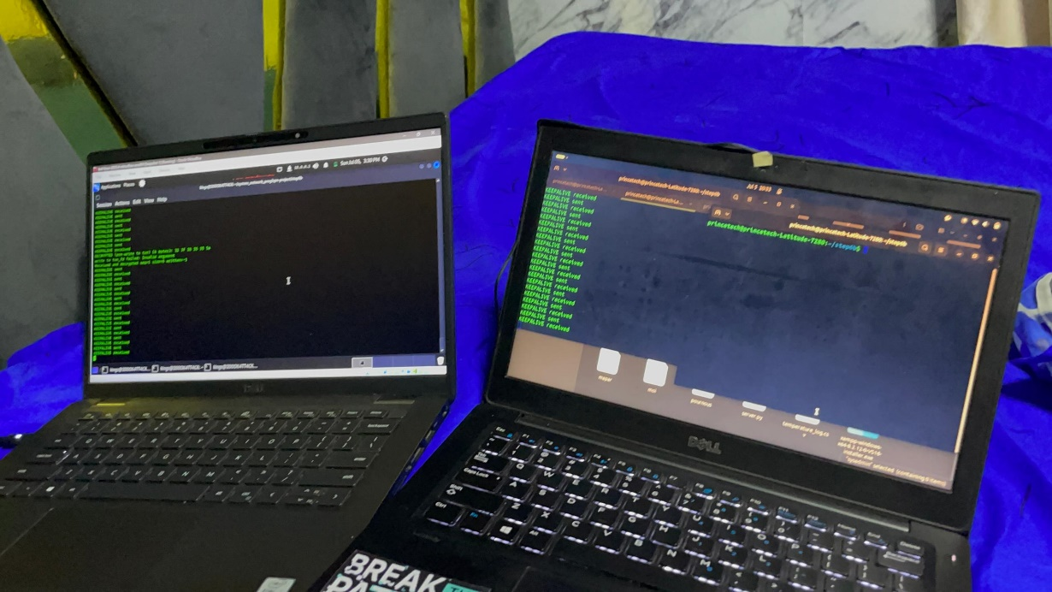
Figure 5: keepalive packets being sent and monitored by each machine to check connectivity

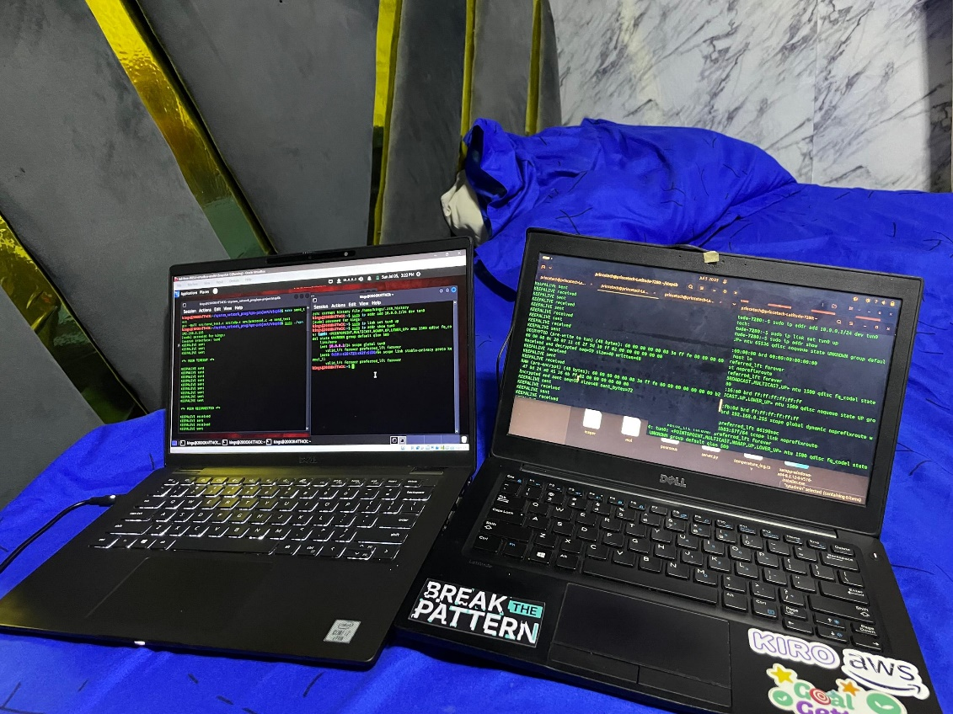
Figure 6: encrypted and decrypted packets being sent to each machine

Appendix F: Glossary
Term | Meaning
Authentication | The process of verifying that a communicating peer is allowed to participate in the VPN connection.
Encapsulation | The process of wrapping one packet inside another packet so that it can be transmitted through a different network protocol.
Encryption | The process of converting readable data into an unreadable form to protect it during transmission.
File Descriptor | A number used by Linux to identify an open file, socket, or device such as a TUN interface.
ICMP Echo Request | A network message sent by the ping command to test whether another device is reachable.
Keepalive Packet | A small control packet sent periodically to confirm that the remote VPN peer is still active.
Packet | A unit of data transmitted across a computer network.
Packet Loss | The failure of one or more packets to reach their destination during transmission.
Peer | One of the machines participating in the VPN tunnel.
Pre-shared Token | A secret value known by both VPN peers and used to authenticate incoming packets.
Sequence Number | A number added to packets to track their order and support future replay protection.
TUN Interface | A virtual Layer-3 network interface used to capture and inject raw IP packets in Linux.
Tunnel | A private communication path created by encapsulating packets inside another transport protocol.
UDP Socket | A communication endpoint used to send and receive UDP datagrams between machines.
Virtual Private Network | A technology that creates a secure private connection across an untrusted or public network.
XOR Cipher | A simple encryption method that applies the XOR operation to data using a fixed key.
Table 11: Glossary

